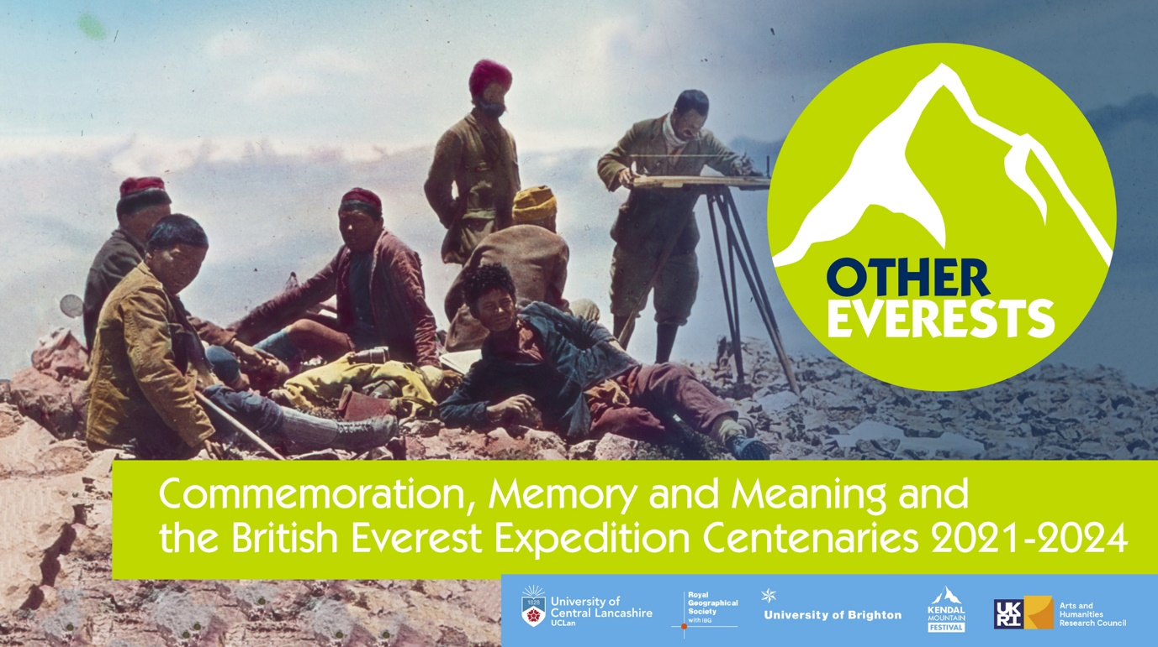

AHRC Network Symposium - Other Everests: Commemoration, Memory and Meaning and the British Everest Expedition Centenaries, 2021-2024.
Dates: 5 – 6 July 2022
Venue: Royal Geographical Society (with IBG), 1 Kensington Gore, London, SW7 2AR.
Rooms: RGS (with IBG) Education Centre, Foyle Reading Room.
Convenors: Dr. Jonathan Westaway, (University of Central Lancashire, UK); Dr. Paul Gilchrist, (University of Brighton, UK).
Project Partners: The Royal Geographical Society-Institute for British Geographers, Kendal Mountain Festival.

Symposium Programme
Tuesday 5 July 2022

10:00 – 10:30 | Arrival, Registration, Refreshments
10:30 – 11:30 | Network Introduction
10:30 – 10:45 - Dr. Jonathan Westaway, Dr. Paul Gilchrist – Overview of network objectives, outline of symposium, housekeeping.

10:45 – 11:30 - Alasdair MacLeod, Head of Enterprise and Resources, RGS-IBG - Introduction from our hosts at the RGS and ‘hands on’ exploration Everest related archives and artefacts in the Foyle Reading Rooms.

[Network participants will be able to request items for viewing prior to the event].

11:30 – 12:45 | Plenary [Format: 40 minutes presentation + discussion].
 | Chair: Dr. Jonathan Westaway
 | Prof Felix Driver, Royal Holloway, University of London, UK.
 | Title: Other Everests: The Expeditionary Archive Re-Visited
 | Abstract: The centenary of the first Everest expeditions offers an opportunity to consider what role archival collections have played and could play in the making of new histories of exploration and mountaineering. The way the story of these expeditions was told in word and image in the first half of the twentieth century has weighed heavily on subsequent re-tellings across a variety of media, from film to fiction. However, the collections they generated also have the potential to inform radically different versions of this history, foregrounding the role of colonial infrastructure, expeditionary labour and Indigenous agency. To realise this potential, it is necessary to embrace an expanded vision of the expeditionary archive, recognising its multiple forms and affordances in the present. This plenary explores the ways in which the story of the early Everest expeditions has been told and might be re-told using materials in the RGS collection, focusing particularly on the avalanche which killed seven porters in 1922. The capacity of expeditionary archives to surprise, challenge, move and inspire – indeed, their wider significance as world heritage - depends partly on what they contain but also on the way they are approached; the questions which are asked of them; the methods used to research and represent them; and the ways in which they are shared with wider and more diverse communities.
12:45 – 13:30 | Lunch
13:30 – 15:00 | Roundtable [Format: 10-15 minutes reflection from each participant, discussion]
 | Chair: Dr. Paul Gilchrist
 | Title: Everest, Images and Archival Knowledges
 | Abstract: As James Ryan argues, ‘scientific institutions such as the RGS have played a central role in conditioning the making, consumption and survival of the imperial photographic archive’ with photography part of an ‘ambitious collective enterprise of visual survey’ that complimented imperial cartographic ambitions. Do photographs operate not as frozen moments of time, but ongoing durations that perpetuate imperial modes of appropriation and dispossession? Is there a commonality of mnemonic regimes of taking and visuality? How can our understanding of the complex relational ontologies of archives, objects and forms of representation help us retell the story of the Everest expeditions? How can we connect with communities represented in the archive? What scope is there for the digital repatriation of archival material and the co-production of interpretive knowledge frameworks? Should archives become sites of conscience, and of restitution, reparation and reconciliation that engage with the knowledge of loss that constitutes the collection?
 | Paula Williams, Curator of Maps, Mountaineering and Polar Collections, National Library of Scotland. [Unfortunately, unable to attend – substitute Jonathan Westaway, RGS- Wiley Digital Archive Fellow, introducing his research on the ethnographic photographs of Major C. J. Morris.]
 | Sarah Pickman, Ph.D. candidate, Yale University - researches the history of exploration, field collecting, natural history museums and anthropology, with a particularly interested in the material culture of expeditions, including expedition provisions, equipment for field science, and collections of field specimens.
 | Alasdair Macleod, Head of Enterprise and Resources, RGS-IBG.
 | Dr. Jan Faull, Independent Scholar – thesis from Royal Holloway, University of London, is entitled Climbing Mount Everest: Expeditionary Film, Geographical Science and Media Culture, 1922 – 1953.
15:00 – 15:15 | Coffee
15:15 – 17:00 | Creative Engagement and Partnerships Space [Format: 15 - 20 minute slots for creative works and partnership profiles, discussion of arts venues and potential projects for follow-on funding for partnerships and engagement].
 | Chair: Steve Brace, Head of Education and Outdoor Learning, RGS-IBG.
 | Title: Representing and Performing Everest
Abstract: This session opens up a space for encounter and reflection and foregrounds arts practitioners and project partners. How can we create the space for diverse knowledges to circulate across the boundaries of the archive? What is the role of artists and practitioners in reimagining archives? How can we create collaborative and creative spaces for audiences and communities to reinterpret the archive? How can artists and practitioners help us reimagine the very act of commemoration and make it meaningful in a post-colonial context?
Linked to our core objectives of highlighting the hidden histories of Everest and recontextualizing the Mount Everest Expedition (MEE) centenaries for diverse publics, the network with its project partners aims to submit a follow-on funding bid for impact and engagement to the AHRC to establish and arts and public outreach festival linked to the 2024 MEE centenary. Key objectives will be:
- To commission work by Indian, Nepalese and Tibetan artists and practitioners
- To foster collaborations between archives and artists and practitioners
- To commission site specific work that makes the link between mountain spaces in the UK and the Himalaya.
- To broaden access to commemorative cultural outputs and activities produced in the UK, to make them more widely accessible throughout the broader Everest region.
- To develop contacts with community groups and practitioners within the Everest region.
- To ensure that all research collaborations with individuals and groups from Low- and Middle-Income Countries (LMiC) countries are governed by the Global Code of Conduct for Research in Resource Poor Settings https://www.globalcodeofconduct.org/
 | Dr. Yvonne Reddick, Research Fellow in Modern English and World Literatures (University of Central Lancashire, UK) – AHRC Leadership Fellow and multi-award-winning poet Yvonne Reddick will give a poetry reading reflecting on the evidence of climate change she experienced on her recent trip to Everest Base Camp.
 | Harvey Wilkinson, Curator, National Trust in the Lake District, UK – will outline co-partnering opportunities and the exhibition spaces the National Trust are making available to the Other Everests network in 2024. These include refurbished exhibition space at Wray Castle and mural space at Allan Bank, Grasmere, Cumbria, as well as other indoor and outdoor sites.
 | Paul Scully, Arts Officer, Kendal Mountain Festival, UK – will outline the work of the festival, its global reach, its unique relationship with a mountaineering audience, available exhibition spaces and opportunities for programming Other Everests themed events at KMF 2022, 2023, 2024. https://www.kendalmountainfestival.com
Mridu Rai, Anthropology Ph.D. candidate, University College London, UK and co-founder of The Confluence Collective, Kalimpong, West Bengal, India https://www.theconfluencecollective.com/ - will outline her recent exhibition at the Royal Anthropological Institute How Do I Bring You Home? https://therai.org.uk/the-rai-photographic-library/mridu-rai-exhibition-how-do-i-bring-you-home
She will introduce the work of The Confluence Collective, their use of visual ethnographic methods and their development of a digital photographic archive of the Sikkim-Darjeeling region and its critical engagement with the legacies of empire.

17:00 – 18:00 | Non-alcoholic drinks social and networking.
Wednesday 6 July 2022

09:30 – 10:00 | Arrival, Refreshments.
10:00 – 11:15 | Plenary [Format: 40 minutes presentation + discussion].
 | Chair: Dr. Shae Frydenlund, Department of Geography, University of Colorado Boulder, USA.
 | Assoc. Prof. Jayeeta Sharma, Department of Historical and Cultural Studies, University of Toronto, Canada.
 | Title: Connecting ‘Hidden’ Himalayas and High-Altitude Circulatory Labour Histories
 | Abstract: This plenary talk connects disparate archives on the Eastern Himalayas to historicize how footloose, labouring children, men, and women constituted the embodied, yet the ‘hidden’ in plain-sight infrastructure of mountain empire. It explores how raced and nation-focused typologies of the imperial and post-colonial eras influenced the silo-ing and silencing of such histories within the narrow limits of disciplinary sub-fields. Finally, it considers what multi-species approaches and multi-sited dissemination strategies might entail for historians of the Anthropocene who seek to consider how to decentre and decolonize knowledge practices beyond Everest.
11:15 – 11:30 | Coffee
11:30 – 12:45 | Roundtable [Format: 10 minutes reflection from each participant, discussion]
 | Chair: Prof. Felix Driver, Royal Holloway, University of London, UK.
 | Title: Encountering Indigenous High-Altitude Labour
 | Abstract: Whose history are we commemorating?’; ‘What are the sources for the history of indigenous high-altitude labour?’; ‘How do we incorporate perspectives from Nepal, Sikkim, Bhutan and Tibet in our research?’ How do late imperial meta-narratives perpetuate racial stereotypes and continue to inform the quasi-colonial relations of production on the mountain? How are both the political economy of labour and indigenous high-altitude labour hierarchies changing? How does history continue to shape contemporary attitudes within globalized mountaineering cultures towards indigenous migrant labour? Is migrant labour treated as ‘adventure’ in new globalized typologies of race? Will the emergence of Nepalese mountaineering record breakers like Nimsdai Purja help to shine a spotlight on the historical contribution of indigenous high-altitude mountaineers?
Nokmedemla Lemtur
Ph.D candidate, Centre for Modern Indian Studies, University of Göttingen, Germany – researches Himalayan mountaineering expeditions and labour in the early 20th century, utilizing German mountaineering archives as part of the Modern India in German Archives, 1706-1989 project.

Himani Upadhyaya
Ph.D. candidate, Ashoka University, India – researches mapping and surveying practices in the Himalayas in the colonial period utilizing historical maps, private papers, and correspondences of colonial officials and naturalists who were associated with topographical and trigonometrical surveys in the British Kumaon region.

Dr. Shae Frydenlund
Department of Geography, University of Colorado Boulder, USA.

12:45 – 13:30 | Lunch
13:30 – 14:45 | Roundtable [Format: 10 minutes reflection from each participant, discussion]
 | Chair: Dr. Paul Gilchrist
 | Title: Globalization on Everest
 | Abstract: The environmental philosopher Michael Marder has described mountain summits as a ‘state of exception where neither political law nor the habitus of everyday life apply.’ Situated on an international border, Everest has long operated as a boundary object. To the south lies Nepal, a state high on the Fragile-State Index beset by natural disasters and political instability. To the north lies Chinese occupied Tibet, a state with territorially maximalist ambitions. Drawing on insights from James C. Scott’s Zomia Thesis to what extent can we theorize Everest as a ‘non-state space’ colonized first by imperial mountaineering ambitions and then by globalized adventure tourism? Everest has now become a transnational signifier of prestige that has successfully been marketed and monetized by global commercial outfitters. What are the psychological, cultural and nationalistic imperatives that drive the commodification of Everest? How has adventure tourism transformed the lives of the communities involved in servicing the industry? Will the emergence of Nepalese owned commercial outfitters transform economic opportunities in the region? How is climate change effecting the long-term sustainability of the tourism industry on Everest?
Jase Wilson
Ph.D. candidate, School of Events, Tourism and Hospitality Management, Leeds Beckett University, UK – research into mountaineering and adventure tourism on 8,000m peaks in the Himalaya, undertaking ethnographic fieldwork focusing on emotional dynamics in high-altitude mountaineering in Central Asia.

Dr. Jenny Hall
York Business School, York St. John University, UK.

Dr. Nathan Smith
Centre for Trust, Peace and Social Relations, University of Coventry.

14:45 – 15:00 | Coffee
15:00 – 16:15 | Plenary [Format: 40 minutes presentation + discussion].
 | Chair: Dr. Abbie Garrington, English Studies, Durham University
 | Prof. Peter Hansen, International and Global Studies, Worcester Polytechnic Institute, USA.
 | Title: The Whiteness of Mount Everest
 | Abstract: In 2022, the “Full Circle Everest Expedition” aimed to scale the mountain to become the “first all-black and brown expedition to the highest place on earth.” The whiteness of Mount Everest has been a distinctive feature of the peak from its naming in the nineteenth century through the many climbing expeditions in the twentieth century. This presentation reviews this longer history of whiteness on Mount Everest as its summit became a height of white masculinity for climbers from the Global North. More recent controversies over the commercialization of Everest, the increasing prominence of Sherpas and Nepalis on the mountain, and the growing diversity among climbers from the Global South and the Global North remain entangled in this history as they demonstrate the limits as well as the potential of possible projects on the mountain.
16:15 – 16:30 | Break
16:30 – 17:15 | Reflection and next steps:  - Guiding principles for collaboration.  - Process for submitting proposals for an Open Access collection of essays with UCL Press.  - Convening steering group, meetings and timeline for AHRC follow-on funding for impact and engagement to deliver an arts and engagement programme in 2024.  - Partnering up and planning for webinars, further publications, events.

